3/4 Modal propositions about nonexistent things

What should a contingentist say about modal propositions about nonexisting things?
Is “Santa Claus possibly exists” actually true?
Is “Possibly Adams exists” true at a world in which he doesn’t exist?
What is the actual truth-value of the counterfactual “if Adams had never existed, he could have existed”?

Line of thought 1 (Adams’s)
The counterfactual is false. If Adams didn’t exist, his existence would not be possible. But his nonexistence wouldn’t be necessary, either! There are no true modal propositions about him at worlds where he doesn’t exist.

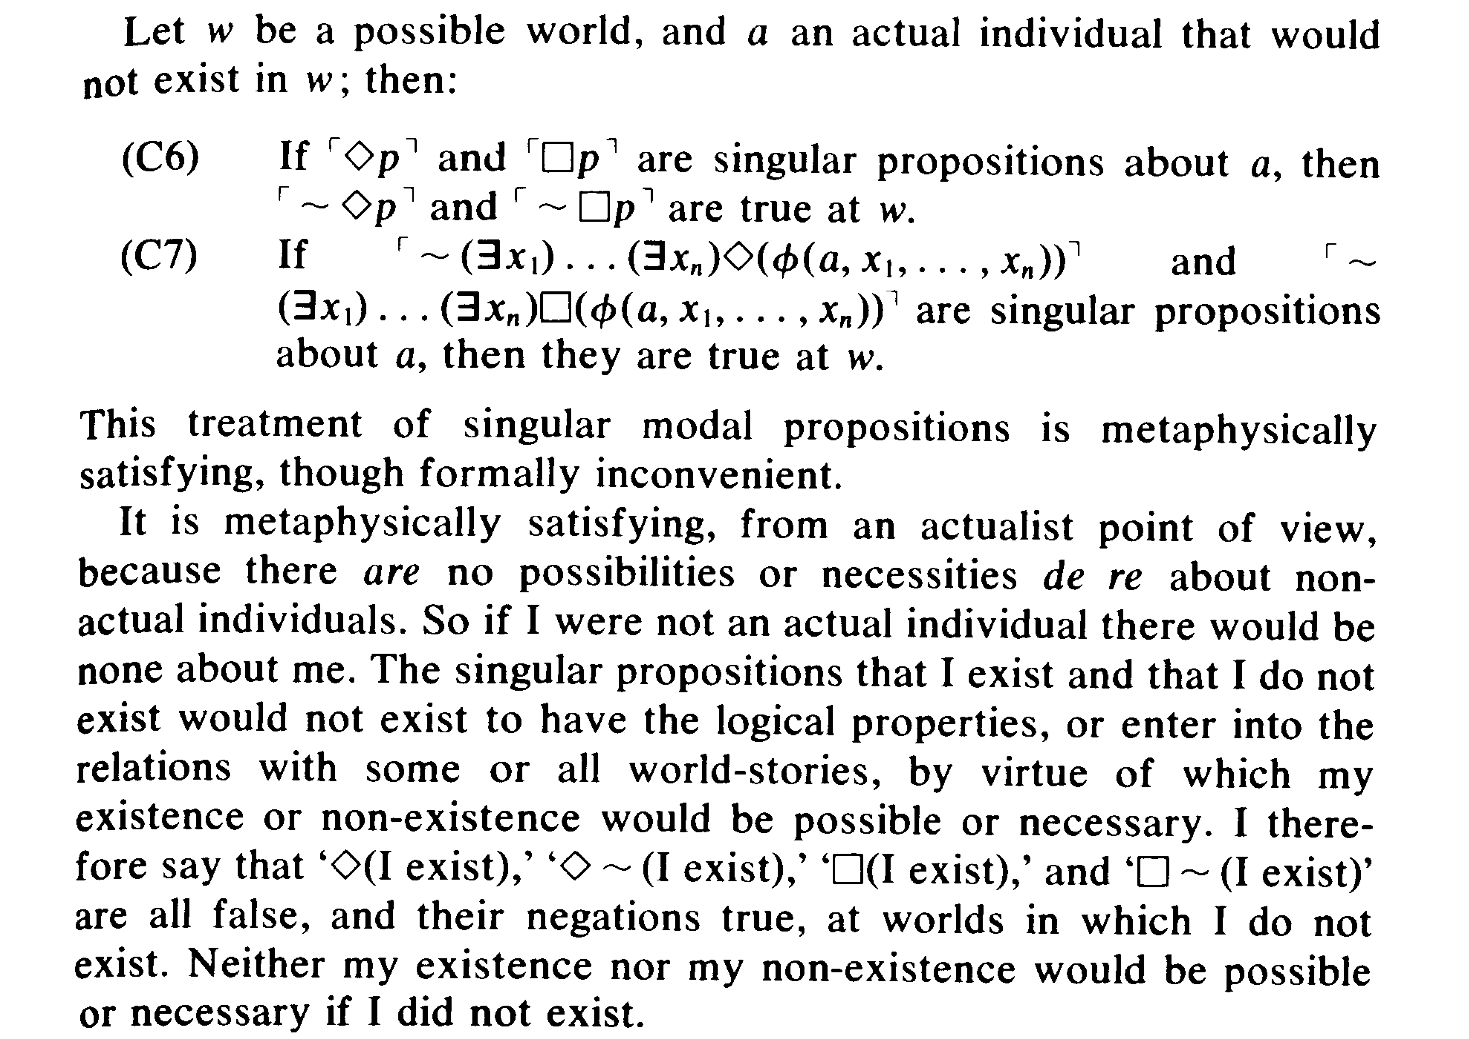

 | truth-value in w? | truth-value at w?
Adams does not exist. | F | T
Possibly, Adams exists. | F | F
Possibly, Adams does not exist. | F | F
Necessarily, Adams exists. | F | F
Necessarily, Adams does not exist. | F | F

Things to notice about this approach:
1. Adams’ semantics doesn’t “give uniform rules for each operator or connective, saying how the semantic value of the complex expression is a function of the semantic values of its immediate constituents” (Stalnaker 97).
2. It requires denying (φ → ◊φ).
3. It requires denying that the modal operators are interdefined as follows: ◊φ ↔ ~~φ.
4. It either requires denying that accessibility is symmetric (and thus denying S5), or (a la Stalnaker) claiming that if a different world were actual, different worlds would exist.

Note here for lack of anywhere else to mention it: There is a very interesting question here about the relation between contingentism and S5, particularly with respect to Stalnaker’s view. On the one hand, he uses an S5 semantics and doesn’t need an accessibility relation. (He doesn’t think that different worlds would be accessible if a different world were actual; he thinks different worlds would exist if a different world were actual. Whatever world is actual, every world can access every world.) But, on the other hand, Stalnaker (maybe?, see below) denies the characteristic S5 axiom: ◊φ → ◊φ.

Line of thought 2 (possibly Stalnaker’s?)
No, ‘◊ Adams exists’ is true at a world where Adams doesn’t exist.

The S5 rule for ‘◊φ’ is that it is true at all worlds in the model just in case φ is true at some world in the model. So ‘◊ Adams exists’ true at w just in case ‘Adams exists’ is true at some world in the model. And it is: it’s true at the actual world.

Now, there is no proposition in w to have the property of possibility: the proposition Adams exists doesn’t exist in w and doesn’t have any properties there, including possibility. But the proposition actually expressed by “possibly, Adams exists” is true.

That is, the idea is to apply the truth in/at distinction to modal claims, not just existence claims. “Possibly Adams exists” is true at or of w even though it’s not true in w. Or, if you like: ‘Adams exists’ is possible at w, but not possible in w.

 | truth-value in w? | truth-value at w?
Adams does not exist. | F | T
Possibly, Adams exists. | F | T
Possibly, Adams does not exist. | F | T
Necessarily, Adams exists. | F | F
Necessarily, Adams does not exist. | F | F

Textual evidence for this interpretation of Stalnaker:
• p. 100: the distinction between inner and outer truth “brings with it a distinction between inner and outer possibility”.

• “it will not in general be true that (◊φ↔ Pπφ)” (100). That is, it will not in general be the case that the truth of a sentence prefaced with the possibility operator entails that the proposition the inner sentence expresses has the property of being possible.
On line of thought #2, ‘◊Adams exists’ is true at w even though the proposition expressed by the sentence ‘Adams exists’ does not have the property of being possible at w.

• There is a distinction between the claim “i) that if world w were realized, it would be true that the proposition that φ was possible, and [the] claim (ii) that the proposition that φ is possible is true with respect to w” (102).

Textual evidence against this interpretation of Stalnaker
• “There is a close connection between the predicates and the corresponding operators: ◊φ… should be true if and only if the proposition that is the value of the sentence φ has the property of being possible” (99). (Note that this appears to contradict the second quote above).

• “given these distinctions, we can distinguish two ways of regimenting the claim that if Adams did not exist, it would not then be possible that he did exist. The thesis might be
- (~Ea → ~◊Ea), or
- (~Ea → ~PπEa).
With Adams’s metaphysical assumptions, but the convenient semantics, (i) is true, but (ii) is false” (100).

Possible virtues:
Uniform rules for the modal operators: “convenient semantics”
Retains (φ → ◊φ)
Retains the interdefinability of the operators: ◊φ ↔ ~~φ (I think)
Respects an intuitive difference between the possible existence of actual things at worlds where they don’t exist and the actual possible existence of nonactual things (contrast “possibly Adams exists” at a world where he doesn’t with “possibly Santa Claus exists” at @).

A puzzle:
‘Possibly Adams exists’ is true at w, though not in w.
Had w been realized, there would not have been any worlds in which or at which ‘Adams exists’ is true.
So had w been realized, ‘possibly Adams exists’ would have been false at w.

Related issues about how to understand counterfactuals like, “had Adams not existed, his existence would have been possible” and even the S5 axiom.

A third line of thought???

Further reading:
Adams (1981), “Actualism and Thisness”
Bennett (2005), “Two Axes of Actualism” (the second axis)
Einheuser (2012), “Inner and Outer Truth”
Speaks (2012), “On Possibly Nonexistent Propositions”

